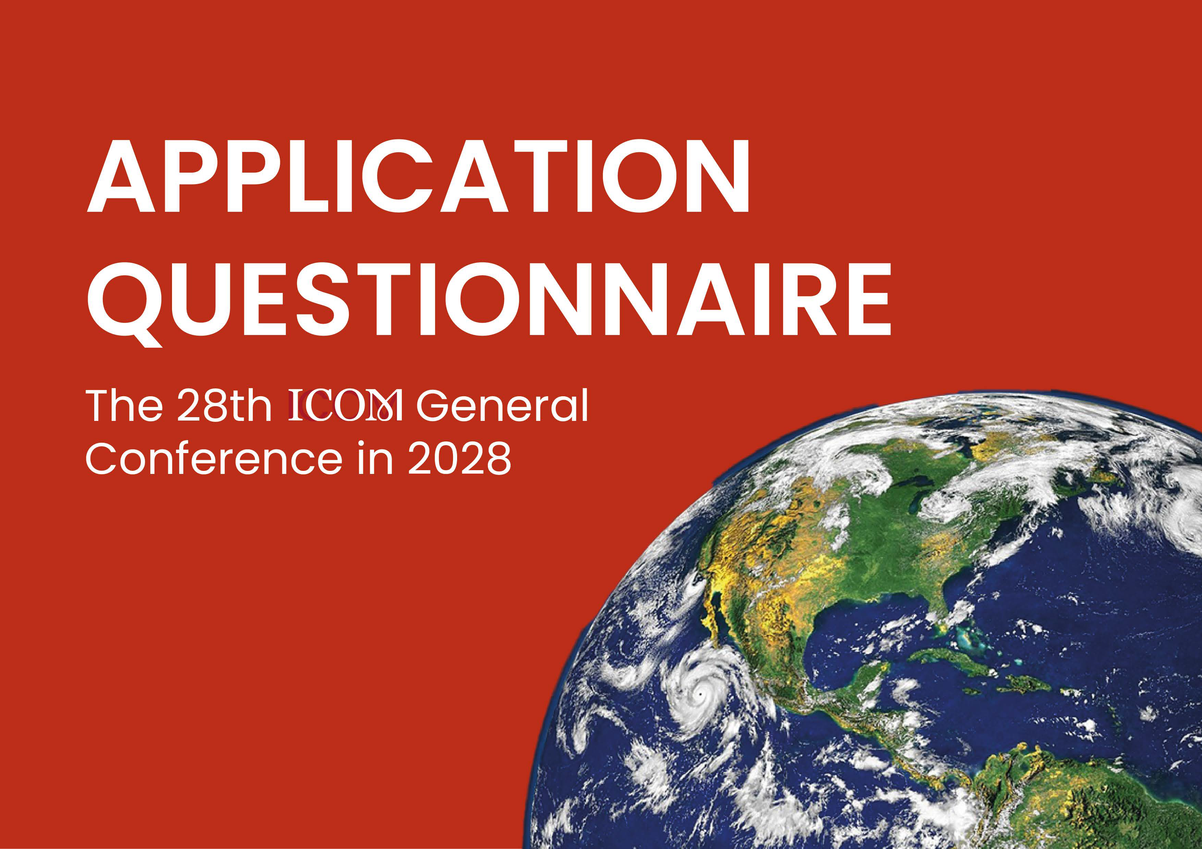

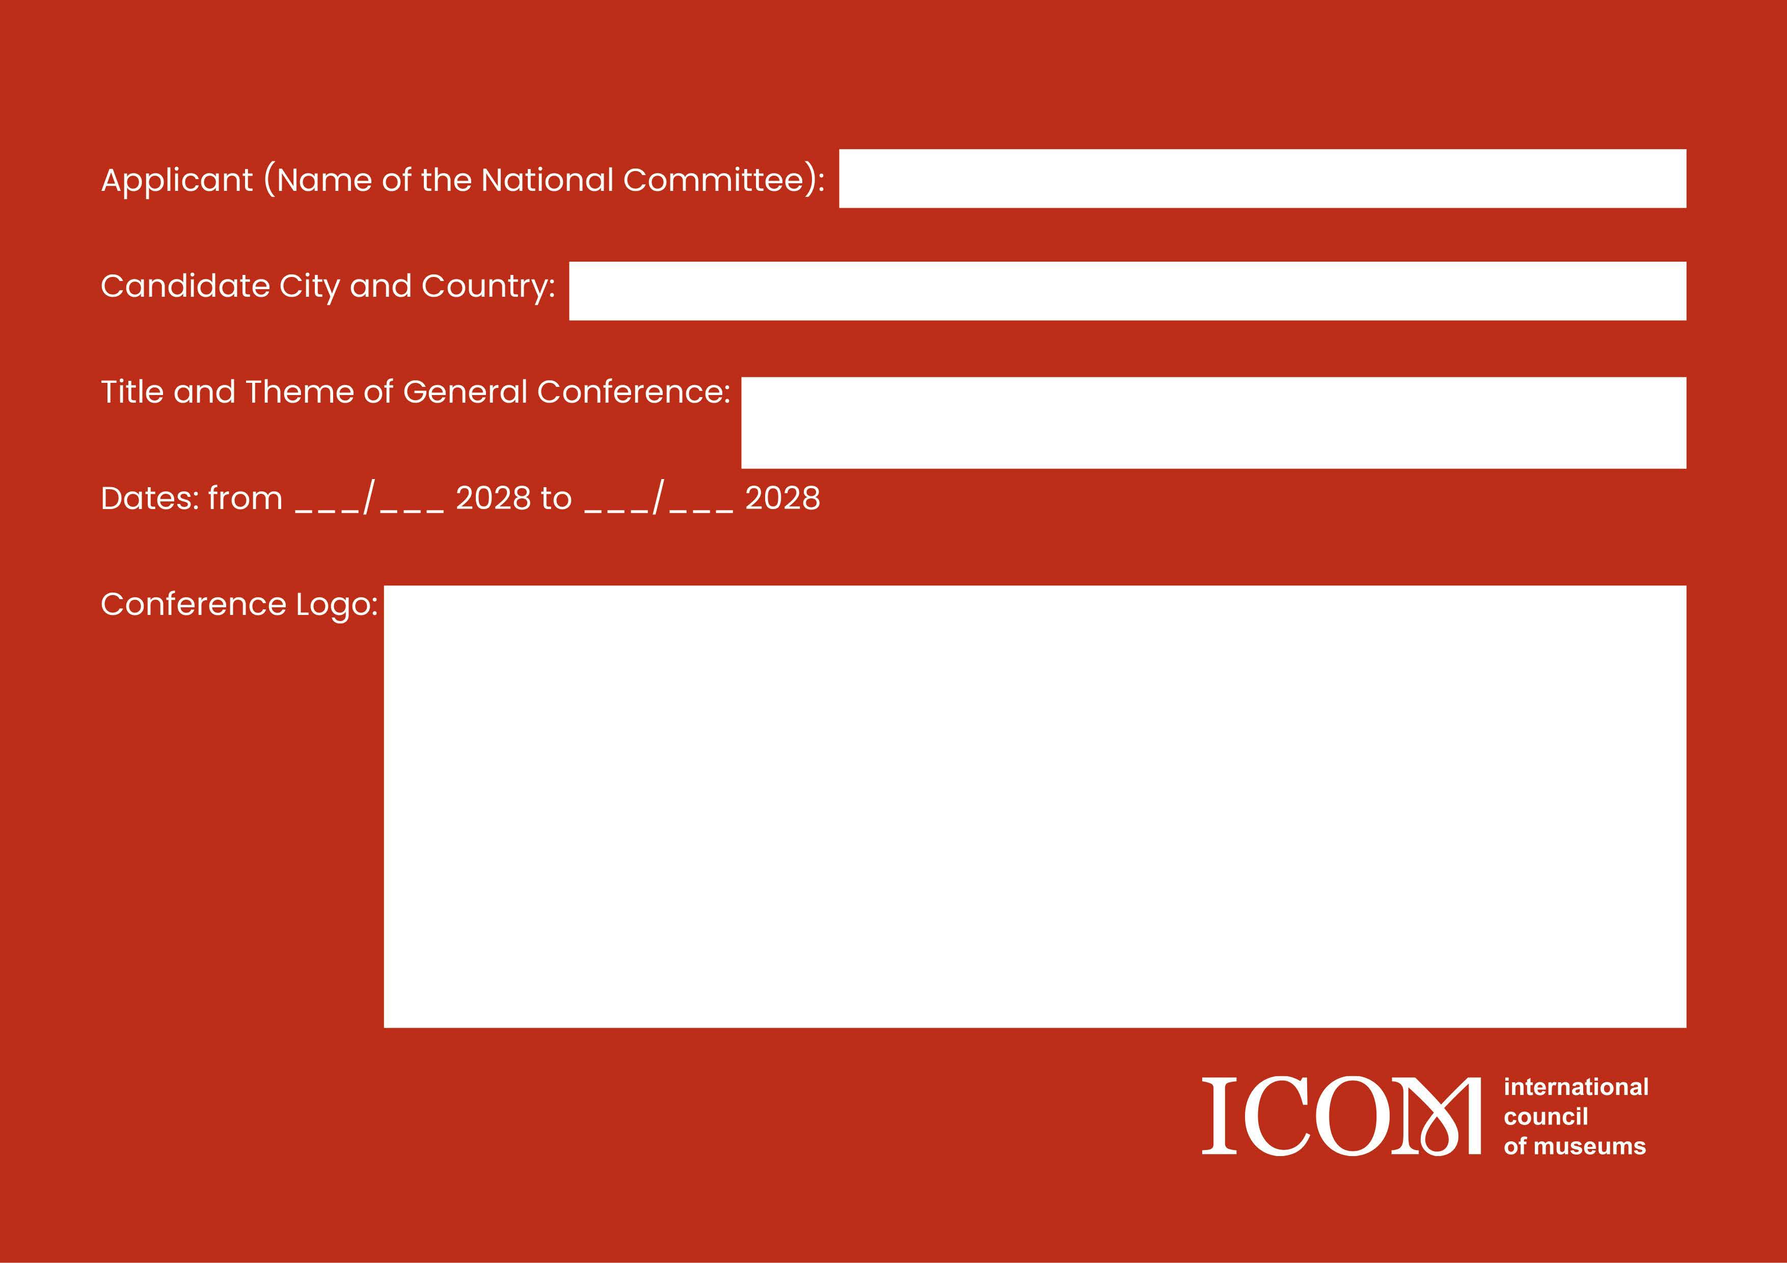

CONTENTS
Legal Undertaking 3
Chapter 1: WHO/WHY – Applicant information and Motivation 5
  - Applicant 5
  - Host city / country 6
  - Supporting authorities 8
  - Professional Congress Organiser (PCO) 8
Chapter 2: WHAT – Uniqueness and Purpose of the Programme 10
Chapter 3: WHEN/WHERE – Venue and Infrastructure 12
  - Conference Venues 12
  - Accommodation 16
  - Travel 17
  - Visa 18
  - Platforms 18
Chapter 4: HOW – Budget Management 19
  - Overview 19
  - Revenues 22
    - Public Contributions and Subventions 22
    - Registration fee 22
    - Museum Fair 23
    - Sponsorships 24
    - Other Revenues 24
  - Expenditures 24
    - Venues and Procurement 24
    - Marketing Plan and Promotion 28
    - Human Resource Management 28
    - Administration 28
  - Financial Oversite 29

LEGAL UNDERTAKING

The National Committee of [please add the legal name of your National Committee such as provided in your By-Laws] (hereinafter referred to as the “National Committee”) declares the following:

- The National Committee functions effectively as provided for in the ICOM Statutes and Internal Rules and, therefore:
  - has adopted is own By-Laws;
  - is registered as an independent, non-governmental, non-profit legal entity with the relevant national authorities;
  - has a minimum of eight (8) members constituting the National Committee
  - has regularly organised and hold plenary meetings and regularly elected its Board

- The National Committee is in good standing in its membership fees for the year 2023.
In consequence thereof, the National Committee declares that it is aware that throughout the selection and review process, the ICOM Executive Board reserves the right to suspend or reorganise the National Committee, as provided for in the ICOM Internal Rules, if the National Committee no longer meets the requirements of a functioning National Committee and/or if the National Committee has acted in flagrant violation of the objectives of ICOM and the ICOM Code of Ethics for Museums. In this regard, the National Committee shall be declared ineligible as a candidate to host city.

- If the National Committee is chosen to host the 28th ICOM General Conference (hereinafter the
“General Conference”), it acknowledges the following:

- It is aware that an agreement (hereinafter the “Agreement”) will be signed with the International Council of Museums (ICOM). The objective of the Agreement is to ensure that the General Conference will (i) comply with ICOM’s statutory and reglementary requirements and (ii) bring together museum and cultural heritage professionals to create synergies, identify common orientations and foster museum cooperation at the international level around the theme proposed by the National Committee in this application file.
- The Agreement will set the terms and conditions of the Parties’ responsibilities, liabilities and obligations for the planning and organisation of the General Conference.
- The National Committee is aware that the Agreement will be drafted, on the basis of the information provided by the National Committee when submitting its application as a candidate, by ICOM and reviewed by all parties. In this respect, the National Committee already agrees, without reservation or amendment, to submit the contract to French law and to choose the relevant French Court of Paris (France) as the competent jurisdiction as well as to comply with the European Union General Data Protection Regulation (EU-GPDR).

- The National Committee undertakes to sign a Memorandum of Understanding (hereinafter the “MoU”) as well as any other legal document deemed necessary by ICOM, such as, but not limited to, a non-disclosure agreement (NDA), prior to the signing of the Agreement. The MoU aims to provide a framework for the pre-contractual relationship as well as to guarantee the commitment and capacity of the National Committee to host the General Conference and to ensure the smooth running for the organisation of the General Conference.

- In consequence thereof, the National Committee the declares that:

- During the application process, the National Committee will refrain from becoming a party to, approving or consenting to any act, contract, commitment or any other action contrary to or likely to affect any of the obligations stipulated in the Agreement.

- If the National Committee has already entered into or approved or consented to a commitment which would be in conflict with, jeopardise, prevent or render impossible the fulfilment of any provision of the Agreement, it shall immediately bring to the attention of ICOM all such commitments. The National Committee declares that all such commitments shall be neither enforced nor enforceable against ICOM and that such commitments shall be deemed, as far as ICOM and any party with which ICOM may enter into an agreement with regard to the ICOM General Conference, to be null and void, unless specifically requested and/or approved in writing by ICOM. In addition, the National Committee shall take all necessary measures to terminate or cause to be terminated any such commitments which would be contrary to the obligations stipulated in the Agreement.

- The National Committee has ensured that it shall not damage ICOM image and/or reputation. In this respect, it shall ensure that the ICOM logo and trademark are protected in the name of ICOM and/or that it has obtained or will obtain from its government and/or its competent national authorities adequate and continuous legal protection to the satisfaction of ICOM and in the name of ICOM. The National Committee has brought this provision to the attention of its government and its competent national authorities and confirms that its government and its relevant national authorities have approved its content.

- The National Committee declares that any dispute arising in the course of the application process, in relation to this Legal Undertaking, will be first subject to conciliation and mediation before being referred to and settled by the relevant French Courts of Paris, France. French Law shall be exclusively applicable to this Legal Undertaking.

- The National Committee reiterates its undertaking to abide by the ICOM Statutes and the ICOM Internal Rules and comply with the ICOM Code of Ethics for Museums.

- This Legal Undertaking shall remain in full force and effect until the Agreement is signed by all the Parties.

The ICOM National Committee of Represented by:
Title Name: Date:
Signature

CHAPTER 1: WHO/WHY – APPLICANT INFORMATION AND MOTIVATION

Applicant
[Q.1] General Information
Please provide the following information:
Candidate City:
Name of the ICOM National Committee: Number of ICOM members in your country: Board Members
Role | Name | Elected date (first and second mandate) | Institution | Title
Chair |  | DD/MM/YYYY
Vice Chair |  | DD/MM/YYYY
Treasure |  | DD/MM/YYYY
Secretary |  | DD/MM/YYYY
Member |  | DD/MM/YYYY

Additional organisations who support the application (if any)
*Add rows if necessary

Organisations | Mission and goals | Contact Information (Name, title, email address) | Level of Support (Financial, logistical, promotional, etc.)
*Add rows if necessary

Contact details of the persons responsible for the application
Person 1
Name: Title:
Institution: Address: Email: Telephone:

Person 2
Name: Title:
Institution: Address: Email: Telephone:

[Q.2] Motivation
Please state your main reasons for applying to host the General Conference. What benefits do you expect and can you bring at local, national, regional and international level? What is the most important aim of hosting the ICOM General Conference?

  - Host city / country [Q.3] City – Security
Please provide an overview of the current security situation in the candidate city and country. Are there any notable security concerns, risks, or challenges that event participants should be aware of?

[Q.4] City – Experience in international events
Please provide a detailed overview of the city's existing experience relevant to hosting large-scale international events.

[Q.5] City – Infrastructure
Please provide an overview of your city's infrastructure, transportation network, and accessibility for international participants.

[Q.6] City – Cost of Living
Please provide the estimated daily cost of living in EUR for participants attending the event in the host city. This should encompass accommodation, meals, transportation, and other relevant expenses.

[Q.7] Museums and heritage sites of interest
Please provide a list of museums, as well as heritage sites in the host city and country. [Optional attachment: the letters of support from museums and heritage sites (original + translation in English, French or Spanish).]
List of museums in the host city

Name of museum | Short description/Characteristics | ICOM  membership
 |  | Yes/No
 |  | Yes/No
 |  | Yes/No

List of museums in the host country
*Add rows if necessary

City | Name of museum | Short description/Characteristics | Transportation time from the host city | ICOM  membership
 |  |  | (ex., 30 minutes by local train) | Yes/No
 |  |  |  | Yes/No
 |  |  |  | Yes/No
. *Add rows if necessary
List of heritage sites

Heritage site /  City of interest | Short description/Characteristics | Transportation time from the host city
 |  | (ex., 30 minutes by local train)
*Add rows if necessary

[Q.8] ICOM membership at your country
Please provide an analysis of ICOM membership development since your National Committee was founded. How do you see any potential for the development of ICOM individual and institutional membership in the host country, in the surrounding regions, or even globally, thanks to the organisation of the ICOM General Conference?

  - Supporting authorities [Q.9] Supporting authorities
Please provide a list of authorities in the host city and in the host country who could potentially support the event. [Compulsory attachment: the letters of support from the relevant authorities (original + translation in English, French or Spanish).]
List of authorities in the host city/country

Name of authority | Contact information
*Add rows if necessary

Professional Congress Organiser (PCO)
[Q. 10] Professional Congress Organiser (PCO)
Please provide details of the Professional Congress Organiser (PCO) or any other professional entity that will support you in the preparation and execution of the hybrid event, including information about the events successfully organised.

Name of PCO: Address: Website: Office locations:

List of past projects

Event title | Type | Date | Venue | Organiser(s) | Budget (€) | Number of  participants
*Add rows if necessary

CHAPTER 2: WHAT – UNIQUENESS AND PURPOSE OF THE PROGRAMME

[Q.11] Title and Theme for the General Conference ★★
Please provide a tentative title and the theme statement you intend to propose for the General Conference, including the thematic focus, objectives, and how it aligns with the goals of the event.

[Q.12] Conference Logo ★
Please attach a draft design of the General Conference logo. It must include the wording “ICOM [name of the candidate city] 2028” and a graphic element.
The logo must adhere to the ICOM Graphic Chart (See the Application Manual, Appendix B)

[Q.13] Programme Proposal for International Symposium in 2027 ★★
Please provide a description of the scientific and Social Programme that you are proposing the International Symposium in 2027, including information about the objectives, structure, and key components of both. For a description of the Symposium programme, please refer to the Manual, Specificiets of the Events.

[Q.14] Programme Proposal for the ICOM General Conference in 2028 ★★
Please provide a description of the Scientific and Social Programme that you are proposing the ICOM General Conference in 2028, including information about the objectives, structure, and key components of both. (For a description of the Symposium programme, please refer to the Manual, Specificiets of the Events.

[Q.15] Excursion Programme ★
Please provide details of the proposed excursion plans for one day, two days, and three days. Include information about the destinations, the number of participants each plan can accommodate, the objectives of each excursion, the transportation facilities and any unique experiences or activities planned for each day.

[Q.16] Uniqueness and Purpose of the programmes ★★
Please explain the uniqueness and purpose of proposed conference theme, logo, and programmes, including any information that will highlight how your proposal can contribute to the Key Principals of ICOM General Conference.

[Q.17] Youth Engagement ★★
Please provide an overview of the Youth Engagement that will result from hosting the General Conference to contribute to achieve its Key Principals?

[Q.18] Legacy Project ★★
Please provide an overview of the proposed legacy project that will result from hosting the General Conference to contribute to the development of the local community and international museum community. The following should be described: objectives, goals, impact, sustainability and continuity of the project, collaboration and partnerships, community engagement, measurement and evaluation, integration with General Conference programme.

[Q.19] Evaluation strategy ★★
The immediate and long-term impact of hosting the General Conference and its Legacy Project ([Q.18]) must be able to measurable and evaluated by the Project Team and ICOM. Please suggest some methods and indicators.

[Q.20] Improvements for the online experience ★
What do you suggest maintaining a high level of engagement with online participants? How do you intend to use the virtual platform to facilitate networking opportunities or Social Programme for the online participants?

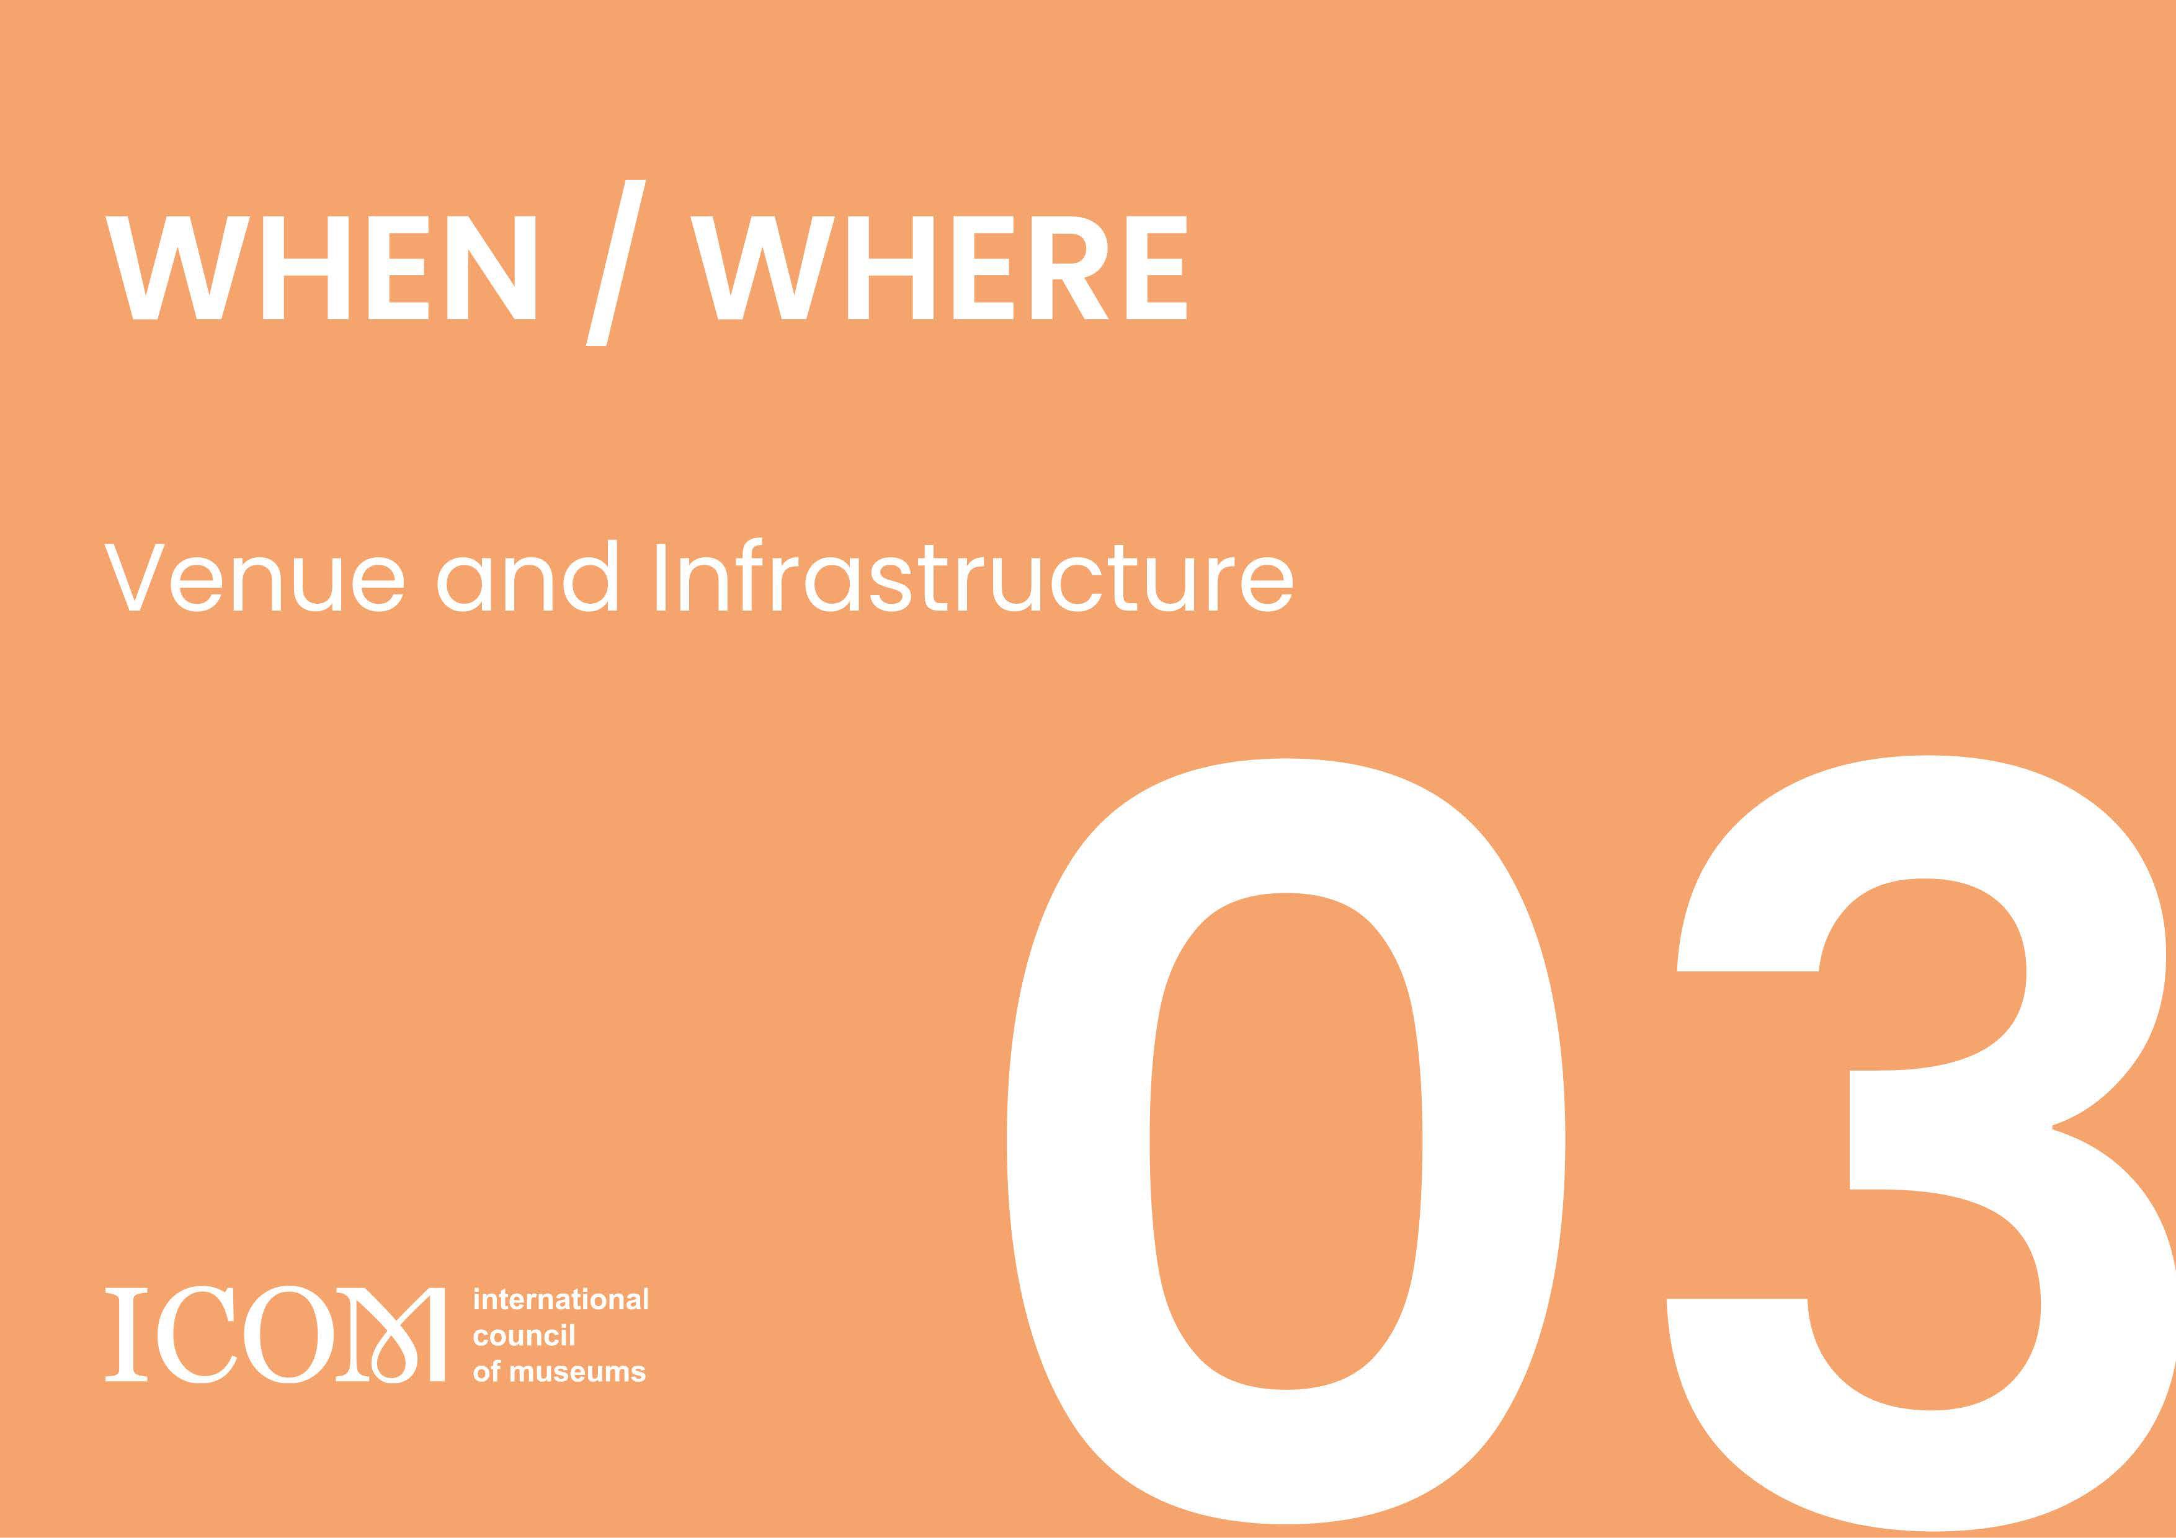

CHAPTER 3: WHEN/WHERE – VENUE AND INFRASTRUCTURE

  - Conference Venues [Q.21] Dates ★
Please indicate the proposed dates for the International Symposium in 2027 and the General Conference in 2028.

[Q.22] Venue for the International Symposium ★★
Please indicate the name and complete address of the venue you are proposing for hosting the International Symposium, including its capacity and facilities. [Compulsory attachment: a city map with the location of the venue for the International Symposium, floor plans, seating plans, room plans, photos, etc.]

Name and Address
Website
Overall capacity
Auditorium | Number of rooms | Room Capacity | Room size (sqm) | Possible Layouts
Break out rooms | Number of rooms | Room Capacity | Room size (sqm) | Possible Layouts

[Q.23] Main venue ★★
Please indicate the name and complete address of the main venue you are proposing for hosting the 28th ICOM General Conference, including its capacity and facilities. [Compulsory attachment: a city map with the location of the main venue, floor plans, seating plans, room plans, photos, etc.]

Name and Address
Website
Overall capacity
Auditorium | Number of rooms | Room Capacity | Room size (sqm) | Possible Layouts
Break out rooms | Number of rooms | Room Capacity | Room size (sqm) | Possible Layouts
Exhibition area (sqm)

[Q.24] Previous events hosted at the main venue ★★
*Add rows if necessary

Please provide a list of previous events of a similar size and profile that have been held in the venue. Please provide as much information as possible by including type of event, the duration, the organiser/co-organiser, and the number of participants.
List of previous events

Event title | Type | Date | Organiser(s) | Number of participants
 | In-person/hybrid

[Q.25] Solution for overflow at the main venue ★
*Add rows if necessary

If there are a greater number of in-person participants for the sessions planned at the auditorium (such as the opening and closing ceremonies and the keynote speeches) than its capacity, what kind of solutions would you propose to deal with the overflow of participants for these events?

[Q.26] Wi-fi at the main venue ★
Please confirm that there is Wi-fi coverage in the whole conference venue, which must be free for ICOM General Conference participants.

[Q.27] Equipment in the meeting rooms at the main venue ★
Please indicate whether you can equip all the meeting rooms with basic devices (a desktop computer with audio output, Wi-fi connection; a video projector and/or screen; conference microphones and/or wireless handheld microphones with the corresponding amplifier system) or provide such equipment upon request.
List of equipment available or provided upon request in the meeting rooms

Equipment | Availability (e.g., pre-equipped, upon request, etc.)
A desktop computer with audio output
Video projector
Conference microphones
Wireless handheld microphones with amplifier system

[Q.28] Museum Fair at the main venue ★★
Please provide a detailed description of the exhibition space available at the congress center, including the total area, layout options, facilities, and any technical capabilities. Additionally, specify how this space can accommodate exhibitors, booths, and interactive displays effectively. [Compulsory attachment: the layout options for the Museum Fair at the main venue]

[Q.29] Previous exhibitions/fairs at the main venue ★★
Please list the previous exhibitions/fairs hosted at the venue, including their sizes, number of exhibitors and booths, and the rental price.
List of past exhibitions/fairs

Exhibition/Fair Title | Size (sqm) | Number of exhibitors | Number of booths | Rental price per square meter EUR
*Add rows if necessary

[Q.30 Emergency and Security Plan at the main venue ★★
Please describe the Emergency and Security Plan in force at the main venue to respond effectively to health and safety incidents and other emergencies that may occur during the General Conference. Please also explain the first aid service that will be guarantee to participants at the main venue during the entire General Conference and list the nearest hospitals and pharmacies.

[Q.31] Other venues – Off-site Meetings of the International Committees ★★
Please indicate the venues (museums, libraries, university, etc.) where you intend to host the Off-site meetings of the International Committees. Please refer to the Manual, Appendix E for the list of ICs. [Compulsory attachment: a map that shows all venues for Off-site Meeting (can be included in the map for Q.22 or attach a separate map)]
Off-site Meetings venues of the International Committees

IC | Venue name | Connections with public transportation | Room capacity | Facilities | Possibility of Live Broadcasting
 |  |  |  |  | Yes/No
 |  |  |  |  | Yes/No
 |  |  |  |  | Yes/No

[Q.32] Other venues – Social Events ★★
*Add rows if necessary

Please provide detailed information about the venues proposed for the Social Events, including their capacity, activities that can be held, connections with public transportation, and any special features that make them suitable for creating memorable and enjoyable experiences for event participants. [Compulsory attachment: a map that shows all other venues, (can be included in the map for Q.22 or attach a separate map)]
Venues for the Social Events

Type of events | Venue | Activity | Event size | Connections with public transportation | Special features
*Add rows if necessary

[Q.33] Admission conditions and special events at the other venues ★
Please explain if the other venues will open their doors to participants free of charge during the ICOM General Conference and if you plan any special events in these venues for the period.

[Q.34] Certifications for the venues to meet sustainability standards ★
Please list any LEED, ISO or equivalent certifications held by the main venue or any other venues mentioned above to ensure they meet sustainability standards. [Optional attachment: any LEED, ISO, or equivalent certifications]

Accommodation
[Q.35] City’s accommodation capacity ★★
Please provide an overview of the city's accommodation capacity, including the total number of hotels, serviced apartments, and other lodging options available for event participants. Include information about the range of accommodation types, average prices (EUR), and their respective capacities.

[Q.36] Accommodation – Participants ★★
Please complete the tables below, where you list the recommended accommodations for the ICOM General Conference participants. [Compulsory attachment: a map with the location of the accommodations (can be included in the map for Q.22 or attach a separate map)]
List of recommended accommodations within walking distance from and to the congress centre (<3 km)

Type | Name | Rating | Number of rooms reservable | Price per night EUR single and double room
hotel, hostel, self-catering, bed and breakfast, campus, etc.
*Add rows if necessary

List of recommended accommodations not within walking distance from and to the congress centre

Type  (hotel, hostel, campus, etc.) | Name | Rating | Number of rooms reservable | Price per night EUR single and double room

[Q.37] Accommodation - ICOM Executive Board and Secretariat, and Speakers ★★
*Add rows if necessary

Please provide some hotel suggestions for the ICOM Executive Board and Secretariat, and conference speakers. [Compulsory attachment: a map to show the location of the accommodations (can be included in the map for Q.22, Q.36, or attach a separate map)]

Travel
[Q.38] Available international airlines and train companies ★★
Please list all international airports and train stations with the name of airlines and train companies that serve direct flights/routes to international distributions. [Compulsory attachment: a map to show the location of international airport(s) and train station(s) (can be included in the map for Q.22, Q.36, or attach a separate map)]
List of international airlines

Airport | Name of airline company | International destinations with direct flights to the host city

List of international train companies
*Add rows if necessary

Train station | Name of train company | International destinations with direct routes to the host city
*Add rows if necessary

[Q.39] Potential discounts ★
Will discounted rates for train and flight transportation be arranged for event participants, and if so, could you please provide details regarding the availability, terms, and booking procedures for these discounts?

Visa
[Q.40] Visa requirements ★
Please attach a list of the nationalities that require a visa to enter in the host country. Please also indicate the cost of the visa for the countries mentioned, and the time required to obtain the visa.
A list of the countries and nationalities mentioned in the host ‘country’s entry policy (list the countries in alphabetical order)

Visa types | Country | Fees (EUR) | Application requirements if any
*Add rows if necessary

Platforms
[Q.41] Registration platform ★★
What is the registration platform you propose for the event? Please provide a description of its features and functionalities, and if available, a demo link.

[Q.42] Event platform ★
What is the event platform you propose for the event? Please provide a description of its features and functionalities, and if available, a demo link.

[Q.43] Online conference platform ★
Please describe the architecture and features of the online conference platform you would like to propose to host the digital conference.

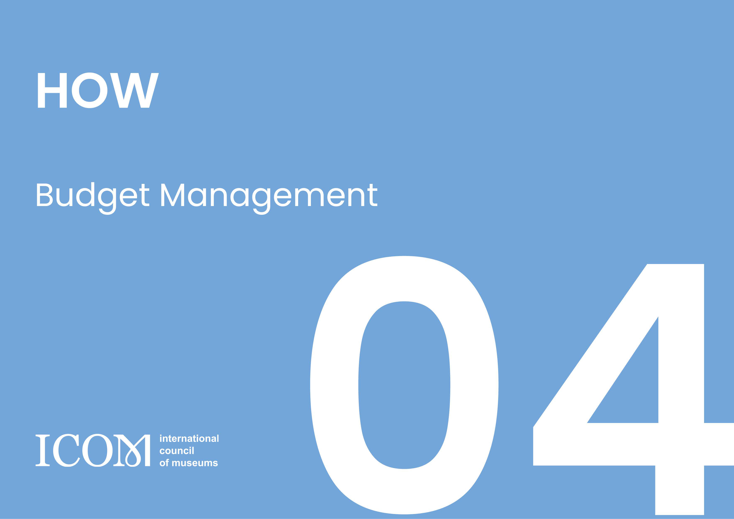

CHAPTER 4: HOW – BUDGET MANAGEMENT

Overview
[Q. 44] Global project plan ★★
Based on the budget, please provide a month-by-month project plan for the organisation of the General Conference from June 2025 until the conference date in 2029. The project plan must provide annual budget flow and monitoring according to the items.

[Q. 45] Global Budget ★★
Please provide an overview of the estimated budget for the organisation of the hybrid ICOM International Symposium and General Conference, specifying revenues and expenditures, with a detailed breakdown in EUR (including taxes as the case may be).

19

Revenues | EUR  (€) | Perc enta ge (%) | Expenditures | EUR  (€) | Perc enta ge (%)
1. Public Contributions and Subventions |  |  | 1. Venues and procurement
"Name of Authority A" |  |  | Rental fees
"Name of Authority B" |  |  | Exhibition space
"Name of Authority C" |  |  | Setup costs
"Name of Authority D" |  |  | Additional services
 |  |  | Security
Subtotal |  |  | Audio-visual
 |  |  | Technical equipment
2. Registration fees |  |  | Catering and meals
Early birds registrations |  |  | Interpretation services
Advance registrations |  |  | Decoration and signage
On-site registrations |  |  | Platforms (registration, event platform, website)
Day Tickets |  |  | Voting system
 |  |  | Wi-fi
Subtotal |  |  | Other expenses
3. Museum Fair |  |  | Subtotal
Booths – S Size
Booths – M Size |  |  | 2. Conference programme
Booths – L Size |  |  | Scientific Programme
 |  |  | Speakers and VIPs
Subtotal |  |  | Social Programme
 |  |  | Excursions
4. Sponsorships
Sponsorship - Type A |  |  | Subtotal
Sponsorship - Type B
Sponsorship - Type C |  |  | 3. Travel Grants
Sponsorship - Type D |  |  | Grant – Type A
 |  |  | Grant – Type B
Subtotal |  |  | Grant – Type C
 |  |  | Grant – Type D
5. Other revenues
Ticketed events |  |  | Subtotal
Advertising
 |  |  | 4. Marketing and Promotion
 |  |  | Promotional material
 |  |  | Publications
 |  |  | Goodies
 |  |  | Marketing Campaigns
 |  |  | Sponsorship and Partnership
 |  |  | Subtotal
 |  |  | 5. Personnel
 |  |  | Project Team costs 2026-2029
 |  |  | PCO costs 2026-2029
 |  |  | Staff during events

 |  |  | Subtotal
 |  |  | 6. Administrative Costs
 |  |  | Travel and Accommodation - Project Team 2026-29
 |  |  | Office costs - Project Team 2026-2029
 |  |  | Travel and Accommodation - ICOM EB and Secretariat 2028
 |  |  | ICOM Licence Fee**
 |  |  | Other expenses
 |  |  | Subtotal
 |  |  | 7. Legal and Insurance
 |  |  | Insurance
 |  |  | Legal consultation
 |  |  | Other expenses
 |  |  | Subtotal
 |  |  | 8. Financial Oversight
 |  |  | Audit Fees
 |  |  | Other expenses
 |  |  | Subtotal
 |  |  | 9. Contingency Fund
 |  |  | Unforeseen expenses
 |  |  | Subtotal
 |  |  | 10. Miscellaneous
 |  |  | Miscellaneous expenses
 |  |  | Subtotal
Total |  |  | Total
Result
** To be articulated at the contractual phase

Revenues

Public Contributions and Subventions
[Q. 46] Public contributions and subventions ★★
Please provide details about the potential public contributions or subventions from relevant authorities that you intend to secure to support the financing of the General Conference. Include information about the name of the granting entity and the amount of the grant in EUR.
[Q.47] Financial Guarantee ★★
Please attach financial guarantees from the relevant entity(ies) which will cover any potential economic deficit on the project and indicate the name and position of your guarantor (original + translation in English or French).

Registration fee
[Q.48] Registration fee policy – Participants ★★
Please propose registration rates in EUR (VAT included), according to the Registration Fee Policy for the ICOM General Conference (see the Manual, Registration Fees). Please also estimate the target number of participants. If you have any suggestions for additional registration categories that can benefit both the participants and project, please feel encouraged to edit the template below.
Proposed registration rates - Participants
In Person Participation Full Ticket |  | Early Bird | Advanced | On-site | Target number
ICOM Member | Category 1-2 Country
 | Category 3-4 Country
 | Category 5 County
ICOM Student Member | Category 1-2 Country
 | Category 3-4 Country
 | Category 5 County
Non-Member
Student
Accompanying Person
Individual Digital Participation Ticket

ICOM Member | Category 1-2 Country
 | Category 3-4 Country
 | Category 5 County
ICOM Student Member | Category 1-2 Country
 | Category 3-4 Country
 | Category 5 County
Non-Member
Student
Institutional Members - Package ticket
Institutional Member | Category 1-2
 | Category 3-4
 | Category 5
In-person Day Pass |  | N/A | N/A

[Q.49] Payment methods ★
Please specify the alternative payment methods (besides credit cards) that participants can use to pay the registration fee online.

Museum Fair
[Q.50] Registration fee policy – Museum Fair ★★
Please propose registration rates in EUR (VAT included) for the different types of booths for the Museum Fair, as well as number of booths you target to reach. Should you also like to organize a virtual fair, please provide the same information.

In-Person Fair
Booth | Equipment (included in the fee) | Rental Fee | Target number
Size S
Size M
Size L
Virtual Fair (Optional)
Type A
Type B
Type C

Sponsorships
[Q. 51] Sponsorship strategy ★★
Please provide a comprehensive overview of your sponsorship strategy for the General Conference and anticipated revenue from sponsorships as well as the target number of sponsors you plan to reach. Include details about the following: target sponsors, sponsorship packages and associated benefits.

Other Revenues
[Q. 52] Potential other source of income ★
Please outline any additional sources of income or revenue streams that you plan to leverage to support the financing of the General Conference.

Expenditures

Venues and Procurement
[Q. 53] Sustainable Strategy and Measures on Procurement ★★
Please provide details about your sustainable procurement strategy for the event, how you aim to prioritize environmental and social considerations in the procurement process. Please address the following points: sustainability objectives, supplier selection criteria, local sourcing and impact, environmental impact assessment, green product and material preferences, packaging and waste reduction, life cycle assessment, reporting and transparency.

[Q. 54] Venue(s) - Rental Policy ★
Please share any policies, guidelines, or terms and conditions related to the venue(s) rental. This could include rules on setup and dismantling timings, noise restrictions, and any venue-specific regulations. In addition, please describe the flexibility of the venue(s) rental terms, such as options for scaling down/up space requirements if necessary, and any associated cost.

[Q. 55] Venue(s) - Rental Fees ★
Please provide a detailed breakdown of the rental costs for the International Symposium, General Conference, and Museum Fair, including the rental days, set-up days, and dismantling days. We kindly request information on the following aspects.

International Symposium
 | Daily rental cost | Additional Fees | N° of Rental Days | Set-Up Days | Dismantling Days
Venue A
Venue B
Venue C
General Conference
 | Daily rental cost | Additional Fees | N° of Rental Days | Set-Up Days | Dismantling Days
Venue A
Venue B
Venue C
Museum Fair
 | Daily rental cost | Additional Fees | N° of Rental Days | Set-Up Days | Dismantling Days
Venue A
Venue B
Venue C

[Q. 56] Catering and Meals ★
Please provide a breakdown of the financial resources designated to ensure quality catering services and meals for attendees, participants, speakers, and staff. Please address the following aspects: estimated cost per person for coffee break and lunch, number of coffee break offered per day, catering style (buffet-style, plated meals, lunch boxes etc.) and cuisine (menu options).

[Q. 57] Interpretation services ★
Please detail the number of interpreters, hourly cost for simultaneous interpretation services and number of devices you will provide to guarantee the simultaneous interpretation of the Statutory Meetings and some sessions of the Scientific Programme (English, French, Spanish) for the in-person and digital event. If applicable, please indicate which languages, other than the three official languages of ICOM, you can provide simultaneous interpretation for these sessions in.

[Q. 58] Voting System ★
Please suggest potential suppliers for the electronic voting system and leasing of devices, as well as their costs, that could be used during the Statutory Meetings (see Manual, Compulsory Requirements).
List of potential suppliers for the voting service and leasing of devices

Supplier | Type of the voting system | Details of the supplier  (Address, Website, Office locations, etc.) | Cost (EUR)

[Q. 59] Platforms ★
*Add rows if necessary

Please provide a breakdown of the budget allocated for technology platforms and solutions, by specific categories (website, registration platform, conference platform etc.)

[Q. 60] Social Events ★
Please provide a detailed budget breakdown for the social events planned as part of the overall programme (opening and closing ceremonies, opening and closing parties and evening social events).

[Q. 61] Excursions ★
Participant's ticket includes a complimentary one-day excursion as part of the event experience. What is the estimated cost (EUR) for the multiple-day excursion that they will incur in case they will register for a two-day or three-day excursion?

[Q. 62] Travel Grants ★★
Please provide a strategy outlining how you intend to secure the necessary funding to offer 80 in-person travel grants and 40 digital grants to ICOM Members. Include information about the name of the granting entity(ies) and programme(s) and the amount of each grant in EUR. (information with respect to the benefits to be included in the grants is given on Manual, Compulsory Requirements)

Funding Agency | Programme | (Grant EUR)
*Add rows if necessary
[Q. 63] Budget breakdown for travel grants ★
Please provide a breakdown of the budget allocation in EUR for a grant for one person intended from the different regions.

Region | Travel |  | Registration Fee | Accommodation | VISA | Total
Africa
Arab States
Asia and the Pacific
Europe
Latin America and the Caribbean
North America
South America
Online | N/A |  |  | N/A | N/A
Total
*Add rows if necessary

[Q. 64] Extra Travel Grants ★
Are you prepared to offer additional travel grants beyond the compulsory grants to support a broader range of participants attending the General Conference?

Marketing Plan and Promotion

[Q. 65] Marketing Strategy ★★
Please describe the marketing strategy and budget to promote the event locally and internationally, outlining the key approaches, channels, targets, and tactics that will be utilized to create awareness and encourage participation.

Human Resource Management

[Q. 66] Project Team of the 28th ICOM General Conference ★★
Please describe the the composition of the Project Team you plan to have for the years 2026 to 2028 responsible for planning and executing the event, detailing key positions and roles within the team, along with the anticipated start and end dates for each position. The minimum staff required is indicated in the Manual, Compulsory Requirements.

Project Team of the 28th ICOM General Conference
Position | Number of staffers | Responsibilities | Start Date | End Date
Project leader
Communication and publication coordinator
Scientific Programme coordinator
Scientific Programme coordinator
Social Programme coordinator
International Committees coordinator
Museum Fair and Sponsorship coordinator
Grants coordinator
Volunteer coordinator
Administration and finance coordinator
*Add rows if necessary

Administration

[Q. 67] Taxes ★
Please provide any available information regarding VAT and other local taxes which will apply to the ICOM General Conference revenues, both for the physical and virtual event, for each revenue item listed in the budget template (Q.45).

[Q. 68] Insurance coverage ★★
Please describe what insurance coverage is being considered for the event, providing details about the types of insurance policies planned, such as general liability, event cancellation, property damage etc. Additionally, explain how insurance requirements will be managed for, exhibitors, and participants.

[Q. 69] Financial Guarantee from the relevant authorities ★★
Please attach financial guarantees from the relevant authorities which will cover any potential economic deficit on the part of the Project Team and indicate the name and position of your guarantor (original + translation in English or French).

Financial Oversite

[Q. 70] Financial Oversite from 2026 to 2029★★
How do you propose to ensure transparent and accountable financial oversight on budget allocation and utilization throughout the entirety of the project? Please outline your strategies, mechanisms, and tools to foster confidence and clarity among stakeholders regarding the financial management processes.
